Longest Bitonic Subsequence
Problem
Given an array a[] of size n, our task is to find the longest bitonic subsequence

Bitonic: Unlike LIS, it can first increase and then decrease.

Possible bitonic subsequences nature
- First increases then decreases
- Only increases
- Only decreases

Example
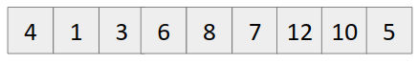
Few subsequences which are valid
{4}, {4,1,3}, {8,7,5}, {1,3,6,8}, {1,3,6,8,12,10,5}, {1,3,6,7,12,10,5}

Maximum Length = 7.

Brute force approach
- Compute all subsequences
- Choose the one with maximum length and following the property of bitonic subsequences.
Time Complexity: O(2^{n})

Optimal Solution (Using dynamic programming)
- Similar to the longest increasing subsequence question.
- Make two tables of LIS,
  - One from starting (LIS1)
  - Other from end (LIS2)
- Iterate over both the tables/ arrays and store the maximum of (lis1[i] + lis2[i]-1).
- Output this maximum value.

